From: <https://www.unz.com/runz/world-war-iii-and-world-war-ii/>

[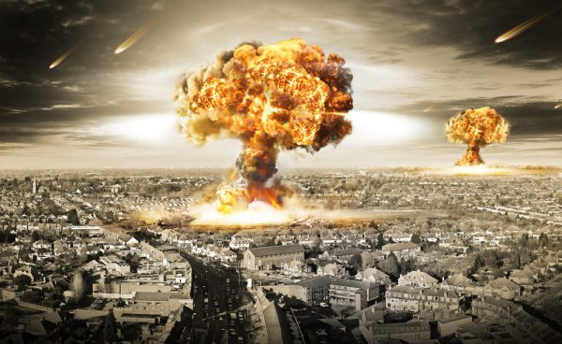](https://www.unz.com/runz/world-war-iii-and-world-war-ii/)

**[](https://www.unz.com/wp-content/uploads/2022/10/Ron_Unz_American_Pravda_World_War_III_and_World_War_II.pdf)**Every now and then, I rediscover the vastness of the Internet.

All this year I’d been quite interested in our conflict with Russia over Ukraine and I’d also begun separately following the public statements of Prof. Jeffrey Sachs of Columbia University, but until last week I hadn’t noticed his late August interview on exactly that subject. Although his appearance on Amy Goodman’s *Democracy Now!* show had accumulated more than two million views, I’d never come across it.

I’d highly recommend listening to his remarks, as well as his similar presentations from earlier this month at the *Grayzone* and on Tulsi Gabbard’s new show.

[**Video Link**](https://rumble.com/embed/v1lwi1j/?t=1240s)

Sachs has spent decades as an elite government insider, whose important and controversial role in Russia began in the early 1990s, so his views on our current predicament should be taken with the utmost seriousness. And they are stark.

As he explains it, America and its NATO allies are currently at war with nuclear-armed Russia on Russia’s own border. Although for now the actual fighting on the ground has been left to our Ukrainian proxies, we are providing all the other military elements—weapons, ammunition, funding, training, intelligence, and coordination—as well as contributing some of the actual combatants. During our long Cold War against the Soviets, such a scenario would have been considered the stuff of nightmares, but it is now the deliberate goal of the American government. The Tulsi Gabbard interview is appropriately entitled “Russia, Ukraine and Preventing Nuclear Holocaust.”

Sachs himself was born in 1954, so he had been a child during the terrifying days of the Cuban Missile Crisis, and that instance of nuclear brinksmanship naturally dominates his thoughts when he considers our current confrontation with Russia. He notes how close the world came to destruction in 1962, saved only by the caution of President John F. Kennedy. Such sentiments are utterly different than those animating today’s Neocon-dominated Biden Administration, which seems eager to escalate the conflict and recently spent days [**casually discussing the use of nuclear weapons against our Russian adversary**](https://consortiumnews.com/2022/10/19/scott-ritter-nuclear-high-noon-in-europe/).

Understanding the past better allows us to assess our current circumstances. But except for the risk of nuclear war, I think that today’s situation is entirely different from that faced during Kennedy’s presidency. In 1962, we almost blundered into a war with the Soviets, a conflict that neither side had actually sought, and our President managed to pull us back from the brink. But in our present confrontation, we have spent years deliberately provoking Russia, avoiding all attempts at achieving a diplomatic resolution and [**even torpedoing Russian-Ukrainian peace talks**](https://www.rt.com/news/562029-ukraine-russia-peace-talks/) when they began in March. Today’s war with Russia is not a mistake, but instead is almost entirely the result of intentional American policy.

Rather than pointing to the 1962 crisis as a model, many leading advocates of our current Ukraine strategy claim that the proper analogy to consider is that of the Second World War, waged against the wanton aggression of Hitler’s Germany. Although Sachs, [**John Mearsheimer**](https://youtu.be/JrMiSQAGOS4) and other knowledgeable individuals have demonstrated that the historical facts are otherwise, nearly all American mainstream media accounts describe the Russian invasion of Ukraine as “completely unprovoked,” often comparing it to the German attack on Poland that unleashed World War II. A couple of weeks after the war began, I published a long article arguing that the latter analogy was actually much more appropriate than many might realize, though not in the way usually understood by its current advocates.

* [**American Pravda: Putin as Hitler?**](https://www.unz.com/runz/american-pravda-putin-as-hitler/)  
  Ron Unz • ***The Unz Review*** • March 7, 2022 • 7,900 Words

Early in my analysis, I had emphasized an important point:

We should recognize that in many respects the standard historical narrative of World War II is merely a congealed version of the media propaganda of that era. If Russia were defeated and destroyed as a result of the current conflict, we can be sure that the subsequent history books would utterly demonize Putin and all the decisions that he had taken.

I explained:

As most of us know, the Second World War began when Germany attacked Poland in 1939 over Danzig, an almost entirely German border city controlled by the Poles.

But less well known is that Hitler had actually made enormous efforts to avoid war and settle that dispute, spending many months on fruitless negotiations and offering extremely reasonable terms. Indeed, the German dictator had made numerous concessions that none of his democratic Weimar predecessors had been willing to consider, but these were all rejected, while provocations increased until war with Poland seemed the only possible option. And just as in the case of Ukraine, politically influential elements in the West almost certainly sought to provoke that war, using Danzig as the spark to ignite the conflict much like the Donbass may have been used to force Putin’s hand.

Prof. Sachs correctly points to our own government having done everything it could to goad the Russians into invading Ukraine, but over the last few years my careful investigation of the outbreak of World War II has led me to a very similar conclusion. If we consider the most reputable contemporaneous sources, we easily discover that the Roosevelt Administration played a central role in instigating the war and also [discover] its motive for doing so.

During the 1930s, John T. Flynn was one of America’s most influential progressive journalists, and although he had begun as a strong supporter of Roosevelt and his New Deal, he gradually became a sharp critic, concluding that FDR’s various governmental schemes had failed to revive the American economy. Then in 1937 a new economic collapse spiked unemployment back to the same levels as when the president had first entered office, confirming Flynn in his harsh verdict. And as [**I wrote**](https://www.unz.com/runz/american-pravda-our-great-purge-of-the-1940s/) last year:

Indeed, Flynn alleges that by late 1937, FDR had turned towards an aggressive foreign policy aimed at involving the country in a major foreign war, primarily because he believed that this was the only route out of his desperate economic and political box, a stratagem not unknown among national leaders throughout history. In [**his January 5, 1938 *New Republic* column**](https://www.unz.com/print/NewRepublic-1938jan05-00254/), he alerted his disbelieving readers to the looming prospect of a large naval military build-up and warfare on the horizon after a top Roosevelt adviser had privately boasted to him that a large bout of “military Keynesianism” and a major war would cure the country’s seemingly insurmountable economic problems. At that time, war with Japan, possibly over Latin American interests, seemed the intended goal, but developing events in Europe soon persuaded FDR that fomenting a general war against Germany was the best course of action. Memoirs and other historical documents obtained by later researchers seem to generally support Flynn’s accusations by indicating that Roosevelt ordered his diplomats to exert enormous pressure upon both the British and Polish governments to avoid any negotiated settlement with Germany, thereby leading to the outbreak of World War II in 1939.

The last point is an important one since **the confidential opinions of those closest to important historical events should be accorded considerable evidentiary weight.** In [**a recent article**](https://www.unz.com/article/roosevelt-conspired-to-start-world-war-ii-in-europe/) John Wear mustered the numerous contemporaneous assessments that implicated FDR as a pivotal figure in orchestrating the world war by his constant pressure upon the British political leadership, a policy that he privately even admitted could mean his impeachment if revealed. Among other testimony, we have the statements of the Polish and British ambassadors to Washington and the American ambassador to London, who also passed along the concurring opinion of Prime Minister Chamberlain himself. Indeed, the German capture and publication of secret Polish diplomatic documents in 1939 had already revealed much of this information, and William Henry Chamberlin confirmed their authenticity in his 1950 book. But since the mainstream media never reported any of this information, these facts remain little known even today.

During 2018 and 2019, I had discussed the origins of World War II and our entrance into that conflict in a couple of lengthy review articles:

* [**American Pravda: Our Great Purge of the 1940s**](https://www.unz.com/runz/american-pravda-our-great-purge-of-the-1940s/)  
  Ron Unz • ***The Unz Review*** • June 11, 2018 • 5,500 Words
* [**American Pravda: Understanding World War II**](https://www.unz.com/runz/american-pravda-understanding-world-war-ii/)  
  Ron Unz • ***The Unz Review*** • September 23, 2019 • 20,500 Words

Once the war began, FDR’s government sought to directly join it on the Allied side but was frustrated by overwhelming public opposition.

Alarmed by their growing fear that America might be drawn into another world war without voters having had any say in the matter, a group of Yale Law students launched an anti-interventionist political organization that they named “The America First Committee,” and it quickly grew to 800,000 members, becoming the largest grass-roots political organization in our national history. Numerous prominent public figures joined or supported it, with the chairman of Sears, Roebuck serving as its head, and its youthful members included future presidents John F. Kennedy and Gerald Ford as well as other notables such as Gore Vidal, Potter Stewart, and Sargent Schriver. Flynn served as chairman of the New York City chapter, and the organization’s leading public spokesman was famed aviator Charles Lindbergh, who for decades had probably ranked as America’s greatest national hero.

Throughout 1941, enormous crowds across the country attended anti-war rallies addressed by Lindbergh and the other leaders, with many millions more listening to the radio broadcasts of the events. Mahl shows that British agents and their American supporters meanwhile continued their covert operations to counter this effort by organizing various political front-groups advocating American military involvement, and employing fair means or foul to neutralize their political opponents. Jewish individuals and organizations seem to have played an enormously disproportionate role in that effort.

At the same time, the Roosevelt Administration escalated its undeclared war against German submarines and other naval forces in the Atlantic, unsuccessfully seeking to provoke an incident that might stampede the country into war. FDR also promoted the most bizarre and ridiculous propaganda inventions aimed at terrifying naive Americans, such as claiming to have proof that the Germans—who possessed no large surface navy and were completely stymied by the English Channel—had formulated concrete plans to leap across two thousand miles of the Atlantic Ocean and seize control of Latin America. British agents supplied some of the crude forgeries he cited as evidence.

These facts, now firmly established by decades of scholarship, provide some necessary context to Lindbergh’s famously controversial speech at an America First rally in September 1941. At that event, he charged that three groups in particular were “pressing this country toward war[:] the British, the Jewish, and the Roosevelt Administration,” and thereby unleashed an enormous firestorm of media attacks and denunciations, including widespread accusations of anti-Semitism and Nazi sympathies. Given the realities of the political situation, Lindbergh’s statement constituted a perfect illustration of Michael Kinsley’s famous quip that “a gaffe is when a politician tells the truth – some obvious truth he isn’t supposed to say.” But as a consequence, Lindbergh’s once-heroic reputation suffered enormous and permanent damage, with the campaign of vilification echoing for the remaining three decades of his life, and even well beyond. Although he was not entirely purged from public life, his standing was certainly never even remotely the same.

From 1940 onward, FDR had been making a great political effort to directly involve America in the war against Germany, but public opinion was overwhelmingly on the other side, with polls showing that up to 80% of the population were opposed. All of this immediately changed once the Japanese bombs dropped on Hawaii, and suddenly the country was at war.

Given these facts, there were natural suspicions that Roosevelt had deliberately provoked the attack by his executive decisions to freeze Japanese assets, embargo all shipments of vital fuel oil supplies, and rebuff the repeated requests by Tokyo leaders for negotiations. In the 1953 volume edited by Barnes, noted diplomatic historian Charles Tansill [**summarized his very strong case**](https://www.unz.com/book/harry_elmer_barnes__perpetual-war-for-perpetual-peace/#chapter-5-japanese-american-relations-1921-1941-the-pacific) that FDR sought to use a Japanese attack as his best “back door to war” against Germany, an argument he had made the previous year in a book of that same name. Over the decades, the information contained in private diaries and government documents seems to have almost conclusively established this interpretation, with Secretary of War Henry Stimson indicating that the plan was to “maneuver [Japan] into firing the first shot”…

By 1941 the U.S. had broken all the Japanese diplomatic codes and was freely reading their secret communications. Therefore, there has also long existed the widespread if disputed belief that the president was well aware of the planned Japanese attack on our fleet and deliberately failed to warn his local commanders, thereby ensuring that the resulting heavy American losses would produce a vengeful nation united for war. Tansill and a former chief researcher for the Congressional investigating committee made this case in the same 1953 Barnes volume, and the following year a former US admiral published [***The Final Secret of Pearl Harbor***](https://www.amazon.com/final-secret-Pearl-Harbor-contribution/dp/B0006ATV54/), providing similar arguments at greater length. This book also included an introduction by one of America’s highest-ranking World War II naval commanders, who fully endorsed the controversial theory.

In 2000, journalist Robert M. Stinnett published a wealth of additional supporting evidence, based upon his eight years of archival research, which was discussed in [**a recent article**](https://www.unz.com/article/pearl-harbor-unmasked/). A telling point made by Stinnett is that if Washington had warned the Pearl Harbor commanders, their resulting defensive preparations would have been noticed by the local Japanese spies and relayed to the approaching task force; and with the element of surprise lost, the attack probably would have been aborted, thus frustrating all of FDR’s long-standing plans for war. Although various details may be disputed, I find the evidence for Roosevelt’s foreknowledge quite compelling.

This historical reconstruction is strongly supported by a wealth of additional detail. During this period, Prof. Revilo P. Oliver had held a senior position in Military Intelligence, and when he published his memoirs four decades later, [**he claimed**](https://www.unz.com/runz/american-pravda-secrets-of-military-intelligence/#p_1_75) that FDR had deliberately tricked the Japanese into attacking Pearl Harbor. Knowing that Japan had broken Portugal’s diplomatic codes, FDR informed the latter country’s ambassador of his plans to wait until the Japanese had over-extended themselves, then order the Pacific Fleet to launch a devastating surprise attack against their home islands. According to Oliver, Japan’s subsequent diplomatic cables revealed they had successfully been convinced that FDR planned to suddenly attack them.

**[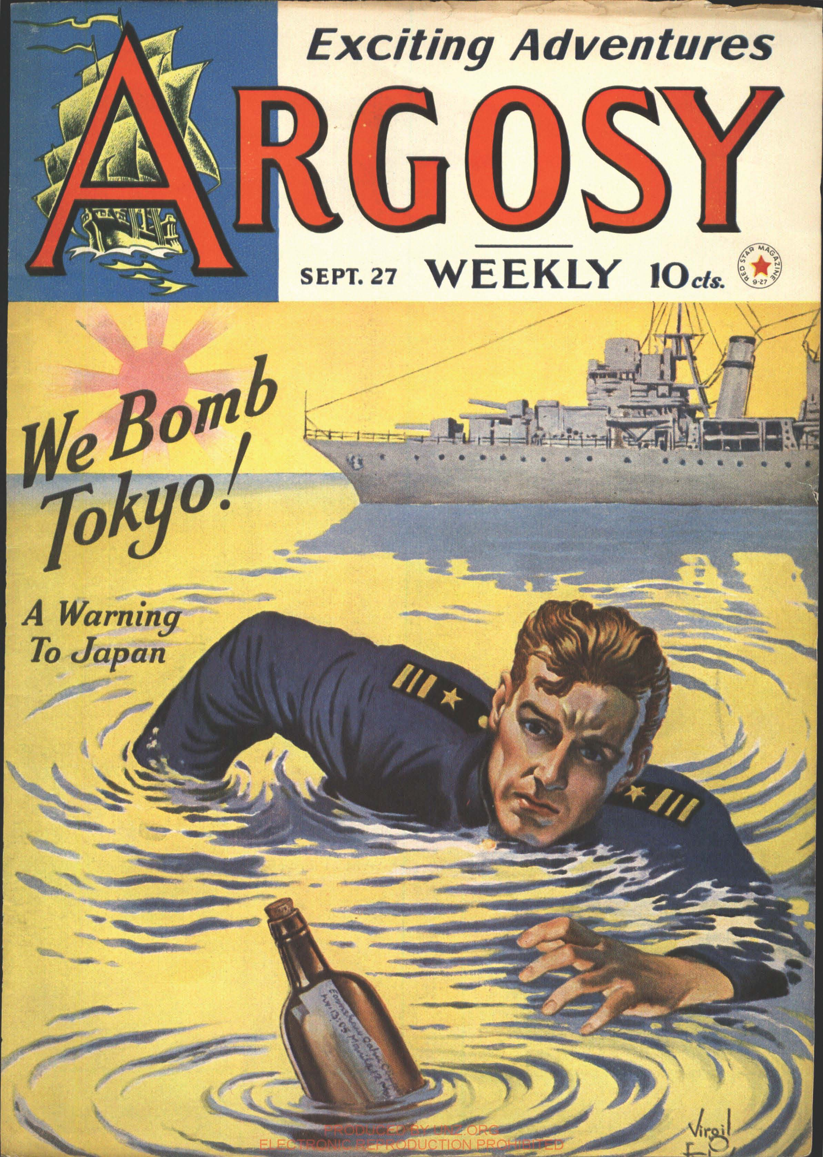](https://www.unz.com/wp-content/uploads/2022/10/ArgosyWeekly-1941sep27-JapanWar.pdf)**

Indeed, just a couple of months before Pearl Harbor, *Argosy Weekly*, one of America’s most popular magazines, carried a fictional cover story describing exactly such a devastating surprise attack on Tokyo in retaliation for a naval incident, with the powerful bombers of our Pacific Fleet inflicting huge damage upon the unprepared Japanese capital. I wonder whether the Roosevelt Administration didn’t have a hand in getting that story published.

As early as May 1940, FDR had ordered the Pacific Fleet relocated from its San Diego home port to Pearl Harbor in Hawaii, a decision strongly opposed as unnecessarily provocative and dangerous by James Richardson, its commanding admiral, who was fired as a result. Moreover:

There was also a very strange domestic incident that immediately followed the Pearl Harbor attack, one which seems to have attracted far too little interest. In that era, films were the most powerful popular media, and although Gentiles constituted 97% of the population, they controlled only one of the major studios; perhaps coincidentally, Walt Disney was also the only high-ranking Hollywood figure perched squarely within the anti-war camp. And the day after the surprise Japanese attack, [**hundreds of U.S. troops seized control of Disney Studios**](https://books.google.com/books?id=I6q6PinOBcQC&pg=PA228&dq=disney+studios+pearl+harbor+watts+good+war&hl=en&sa=X&ved=0ahUKEwit0bmhjsrbAhWML3wKHWnHBjgQ6AEIKTAA#v=onepage&q=disney%20studios%20pearl%20harbor%20watts%20good%20war&f=false), allegedly in order to help defend California from Japanese forces located thousands of miles away, with the military occupation continuing for the next eight months. Consider what suspicious minds might have thought if on September 12, 2001, President Bush had immediately ordered his military to seize the CBS network offices, claiming that such a step was necessary to help protect New York City against further Islamicist attacks.

The attack on Pearl Harbor took place on a Sunday and unless FDR and his top aides were fully aware of the pending Japanese assault, they surely would have been totally preoccupied with the aftermath of the disaster. It seems highly unlikely that the U.S. military would have been ready to seize control of Disney studios early Monday morning following an actual “surprise” attack.

**Just as America had made every effort to provoke a war with Japan in 1941, we seem to be following a similar playbook these days with regard to China.** As [**I wrote**](https://www.unz.com/runz/american-pravda-putin-as-hitler/) earlier this year:

Prior to the outbreak of the Ukraine war, America had spent years primarily focusing its hostility against China, forming a military alliance against that country, deploying sanctions to cripple Huawei, China’s global technological champion, and working to ruin the Beijing Olympics, while also drawing very near to the red-line of actively promoting Taiwanese independence. I have even argued that [**there is strong perhaps overwhelming evidence**](https://www.unz.com/page/covid-biowarfare-articles/) that the Covid outbreak in Wuhan was probably the result of a biowarfare attack by rogue elements of the Trump Administration.

**These extremely provocative actions under Trump have only accelerated after he left office**, including Speaker Nancy Pelosi’s inflammatory official visit to Taiwan a couple of months ago. Then last week, the Biden Administration declared its intent to totally cripple China’s vital domestic microchip industry, issuing new regulations banning all American citizens from any involvement and extending that restriction to all other global companies doing business with Chinese manufacturers. This unprecedented action has been characterized as a sudden “thermonuclear attack” against a vital Chinese industry:

* [**Biden’s Tech-War Goes Nuclear**](https://www.unz.com/mwhitney/bidens-tech-war-goes-nuclear/)  
  Mike Whitney • ***The Unz Review*** • October 17, 2022 • 1,900 Words

As Prof. Sachs emphasized in his late August discussion, we seem to be deliberately provoking a simultaneous confrontation with both Russia and China on issues that they regard as vital to their national security interests.

It might seem utterly irrational for America to force those two world powers into a direct alliance against us, but I suspect that our political elites have become intoxicated from their misreading of American history, including the World War II example they so regularly cite. As [**I explained**](https://www.unz.com/runz/american-pravda-putin-as-hitler/#america-and-the-current-balance-of-power-against-russia) soon after the outbreak of the Ukraine War.

For more than a hundred years, all of America’s many wars have been fought against totally outmatched adversaries, opponents that possessed merely a fraction of the human, industrial, and natural resources that we and our allies controlled. This massive advantage regularly compensated for many of our serious early mistakes in those conflicts. So the main difficulty our elected leaders faced was merely persuading the often very reluctant American citizenry to support a war, which is why many historians have alleged that such incidents as the sinkings of Maine and the Lusitania, and the attacks in Pearl Harbor and Tonkin Bay were orchestrated or manipulated for exactly that purpose.

This huge advantage in potential power was certainly the case when World War II broke out in Europe, and Schultze-Rhonof and others have emphasized that the British and French empires backed by America commanded potential military resources vastly superior to those of Germany, a mid-size country smaller than Texas. The surprise was that despite such overwhelming odds Germany proved highly successful for several years, before finally going down to defeat…

Consider the attitude taken during the current conflict with Russia, a severe Cold War confrontation that might conceivably turn hot. Despite its great military strength and enormous nuclear arsenal, Russia seems just as out-matched as any past American foe. Including the NATO countries and Japan, the American alliance commands a 6-to-1 advantage in population and [**12-to-1 superiority in economic product**](https://en.wikipedia.org/wiki/List_of_countries_by_GDP_(PPP)), the key sinews of international power. Such an enormous disparity is implicit in the attitudes of our strategic planners and their media mouthpieces.

But this is a very unrealistic view of the true correlation of forces…just two weeks before the Russian attack on Ukraine, Putin and Chinese leader Xi Jinping held their 39th personal meeting in Beijing and [**declared that their partnership had “no limits.”**](https://www.reuters.com/world/china/moscow-beijing-partnership-has-no-limits-2022-02-04/) **China will certainly support Russia in any global conflict.**

Meanwhile, America’s endless attacks and vilification of Iran have gone on for decades, culminating in our assassination two years ago of the country’s top military commander, Qasem Soleimani, who had been mentioned as a leading candidate in Iran’s 2021 presidential elections. Together with our Israeli ally, we have also assassinated many of Iran’s top scientists over the last decade, and in 2020 [**Iran publicly accused America**](https://www.unz.com/runz/american-pravda-the-covid-epidemic-as-lab-leak-or-biowarfare/#the-long-forgotten-early-iranian-outbreak) of having unleashed the Covid biowarfare weapon against their country, which infected much of their parliament and killed many members of their political elite. Iran would certainly side with Russia as well.

America, together with its NATO allies and Japan, does possess huge superiority in any test of global power against Russia alone. However, that would not be the case against a coalition consisting of Russia, China, and Iran, and indeed I think the latter group might actually have the upper hand, given its enormous weight of population, natural resources, and industrial strength.

Since the fall of the Soviet Union in 1991, America has enjoyed a unipolar moment, reigning as the world’s sole hyperpower. But this status has fostered our overweening arrogance and international aggression against far weaker targets, finally leading to the creation of a powerful block of states willing to stand up against us.

I wrote those words just two weeks after the war began, and as is inevitable in any conflict, various matters have gone differently than anyone originally predicted.

The Russians had been widely expected to sweep the Ukrainians before them, but instead they have encountered very determined resistance, suffering heavy casualties as they made slow progress. Generously resupplied with advanced weaponry from NATO stockpiles, the Ukrainians recently launched successful counter-attacks, forcing Russian President Vladimir Putin to call up 300,000 reserves.

But although Russia’s military efforts have only been partially successful, on all other fronts, America and its allies have suffered a series of strategic geopolitical defeats.

At the start of the war, most observers believed that the unprecedented sanctions imposed by America and its NATO allies would deal a crippling blow to the Russian economy. Instead, Russia has escaped any serious damage, while the loss of cheap Russian energy has devastated the European economies and severely hurt our own, resulting in the highest inflation rates in forty years. The Russian Ruble was expected to collapse, but is now stronger than it was before.

Germany is the industrial engine of Europe and the sanctions imposed on Russia were so self-destructive that popular protests began demanding that they be lifted and the Nord Stream energy pipelines reopened. To forestall any such potential defection, those Russian-German pipelines were suddenly attacked and destroyed, almost certainly [**with the approval and involvement of the U.S. government**](https://www.youtube.com/watch?v=ALb2FPXFro4). America is not legally at war with Russia let alone Germany, so this probably represented the greatest peacetime destruction of civilian infrastructure in the history of the world, inflicting enormous, lasting damage upon our European allies. Our total dominance over the global media has so far prevented most ordinary Europeans or Americans from recognizing what transpired, but as the energy crisis worsens and the truth gradually begins to emerge, NATO might have a hard time surviving. As I discussed in a recent article, America may have squandered three generations of European friendship by destroying those vital pipelines.

* [**American Pravda: Of Pipelines and Plagues**](https://www.unz.com/runz/american-pravda-of-pipelines-and-plagues/)  
  Ron Unz • ***The Unz Review*** • October 3, 2022 • 3,900 Words

Meanwhile, many years of arrogant and oppressive American behavior towards so many other major countries has produced a powerful backlash of support for Russia. According to news reports, the Iranians have provided the Russians with large numbers of their advanced drones, which have been effectively deployed against the Ukrainians. Since World War II, our alliance with Saudi Arabia has been a linchpin of our Middle Eastern policy, but the [**Saudis have now repeatedly sided with the Russians**](https://www.nytimes.com/2022/10/11/us/politics/biden-saudi-arabia-oil-production-cut.html) on oil production issues, completely ignoring America’s demands despite threats of retaliation from Congress. Turkey has NATO’s largest military, but it is [**closely cooperating with Russia**](https://www.nakedcapitalism.com/2022/10/turkiye-resisting-us-pressure-against-increasing-economic-ties-to-russia.html) on natural gas shipments. [**India has also moved closer to Russia on crucial issues**](https://www.ft.com/content/b38d3ab5-ea57-400e-87e9-f48eaf3e0510), ignoring the sanctions we have imposed on Russian oil. Except for our political vassal states, most major world powers seem to be lining up on Russia’s side.

Since World War II one of the central pillars of global American dominance has been the status of **the US dollar** as the world’s reserve currency and our associated control over the international banking system. Until recently we always presented our role as neutral and administrative, but we have increasingly begun weaponizing that power, using our position to punish those states we disliked, and this is naturally forcing other countries to seek alternatives. Perhaps the world could tolerate our freezing the financial assets of relatively small countries such as Venezuela or Afghanistan, but our seizure of Russia’s $300 billion in foreign reserves obviously tipped the balance, and major countries are increasingly seeking to shift their transactions away from the dollar and the banking network that we control. Although the economic decline of the EU has caused a corresponding fall in the Euro and driven up the dollar by default, the longer-term prospects for our continued currency hegemony hardly seem good. And given our horrendous budget and trade deficits, a flight from the dollar might easily collapse the US economy.

Soon after the outbreak of the Ukraine War, the eminent historian Alfred McCoy argued that we were witnessing the geopolitical birth of a new world order, built around a Russia-China alliance that would dominate the Eurasian landmass. His discussion with Amy Goodman has been viewed nearly two million times.

**Our relentlessly aggressive foreign policy towards Russia and China today constitutes an enormous threat to world peace and our own national future, yet half my article focused on events from more than seven decades ago, presenting a highly unorthodox narrative of the origins of World War II.** Many might regard this material as completely irrelevant, but I disagree.

Consider our [**Secretary of State Antony Blinken**](https://en.wikipedia.org/wiki/Antony_Blinken), one of the key figures formulating our current policies. Prior to his appointment, I’d never heard of him, but I soon discovered that he’d attended the same college that I did, graduating one year later. We may have even shared some classes, though since my major was Theoretical Physics and his was Social Studies, probably not. But I do think that I have a very good understanding of his view of the world and the history of the twentieth century since until the last decade or so mine was probably not too different. Most of the other senior figures in the Biden Administration seem to fall into that same category.

These individuals have **a fixed set of particular beliefs regarding America’s role in the world, beliefs shared by their entire ideological circle, and I’m sure that they would immediately reject any challenges to that framework with regard to Russia or China. Such challenges are probably not uncommon, but are regularly dismissed and ignored.**

However, I suspect that none of them have ever imagined that the deepest foundations of their belief-system—their assumed history of World War II—is actually false and rotten to the core. They have probably never encountered such ideas in their entire lives, and as a consequence, their psychological defenses might be much weaker. And if any of them begins to even consider the slightest possibility that every source of information they have absorbed since elementary school has been based upon the same underlying set of falsehoods, that realization might shake their confidence in contemporary matters, including the circumstances surrounding the current war in Ukraine.

Mules are stubborn animals. But there’s [**a classic joke**](https://www.mikelockett.com/storytelling?rec_id=158) that they can be persuaded to follow directions if you first get their attention by hitting them on the head with a two-by-four. For most American policy-experts discovering that their entire accepted history of World War II is upside-down and backwards amounts to being hit on the head with a two-by-four.

**Related Reading**

* [**Jeffrey Sachs as Righteous Rogue Elephant**](https://www.unz.com/runz/jeffrey-sachs-as-righteous-rogue-elephant/)
* [**American Pravda: Putin as Hitler?**](https://www.unz.com/runz/american-pravda-putin-as-hitler/)
* [**American Pravda: Understanding World War II**](https://www.unz.com/runz/american-pravda-understanding-world-war-ii/)
* [**American Pravda: Our Great Purge of the 1940s**](https://www.unz.com/runz/american-pravda-our-great-purge-of-the-1940s/)
* [**American Pravda: Of Pipelines and Plagues**](https://www.unz.com/runz/american-pravda-of-pipelines-and-plagues/)